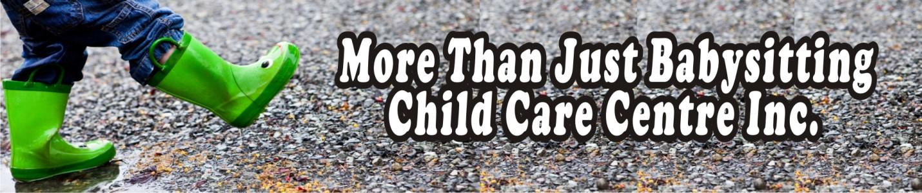2022 FEE RATES - MAYNARD MAIN SITE
PROGRAM | FULL-TIME RATE 2022 | PART-TIME RATE 2022
Infant,  0 to 18 Months | $46.50 | $47.50
Toddler,  18+ to 30 Months | $39.75 | $40.75
Preschool  30+ Months to First Day in Kindergarten | $37.25 | $38.25

MAYNARD MAIN SITE & TR LEGER SITE

PROGRAM | FULL-TIME RATE 2022 |  | PART-TIME RATE 2022
Kindergarten, Blended Rate includes  year-round care for contracted users | $23.75 |  | $24.75
Kinder, Casual User |  |  | $34.50
Kinder, (no school – snow day, educator action, school closed) | $33.75 |  | $34.75
School-Aged, Blended Rate includes  year-round care for contracted users | $19.75 |  | $20.75
School-Aged, Casual User | $34.50
School-Aged, (no school – snow day, educator action, school closed) | $29.75 | $30.75
AM & PM Snacks are served, children must bring a packed lunch.
Kinder rates apply upon your child's first day of kindergarten.
School-age rates apply upon your child's first day of grade 1.

